| Instruction on how to share your answers:  1.Take a picture of your answer or convert to pdf. Using Snipping Tools, cut the area of your answer & paste it on the Google Docs.  2.Write your name before you paste your answer  3.Do Google Search to find an image or website that supports your answer and paste it below your answer (if you have extra time). |
| --- |

Example:

AMIRUL

#include<stdio.h>

int main (void)

{

int count = 0;

do

{

count++;

printf("(%d)PASUM \n",count);

}while (count <= 10);

return 0;

}

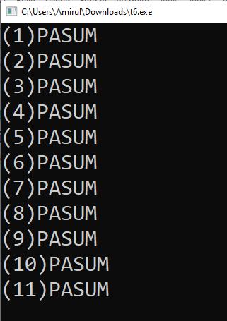

Answer all the questions.

1. What is the output of the following C code?

| (a) | #include<stdio.h>  int main (void)  {  int n=9;  while(n<=50){  printf("%d ",n+3);  n+=3;  } return 0;  }  Answer:  12  15  ..  51 | (b) | #include<stdio.h>  int main (void)  {  int sum = 0,item = 93;  do  {  item++;  sum += item;  if (sum > 100)  break;  }while (item < 97);  printf("Sum is %d\n",sum);  return 0;  }  Answer:  Sum is 189 |
| --- | --- | --- | --- |

1. How many times the following code prints “PASUM”?

| (a) | #include<stdio.h>  int main (void)  {  int c = 0;  while (c < 10)  {  printf("PASUM ");  c++;  }  return 0;  }  Answer:  10 | (b) | #include<stdio.h>  int main (void)  {  int count = 0;  do  {  count++;  printf("PASUM ");  }while (count <= 10);  return 0;  }  Answer:  11 |
| --- | --- | --- | --- |

1. Write a C code for the following flowchart. Assume the user inputs an integer variable.

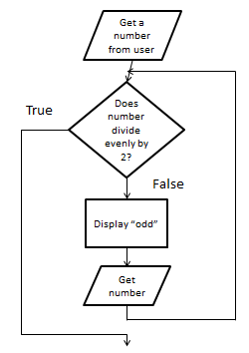

Answers:

DANISH

#include<stdio.h>

int main ()

{

int x;

do{

printf("Enter any integer:");

scanf("%d",&x);

x=x%2;

if(x!=0)

printf("Odd\n");

}

while(x!=0);

return 0;

}

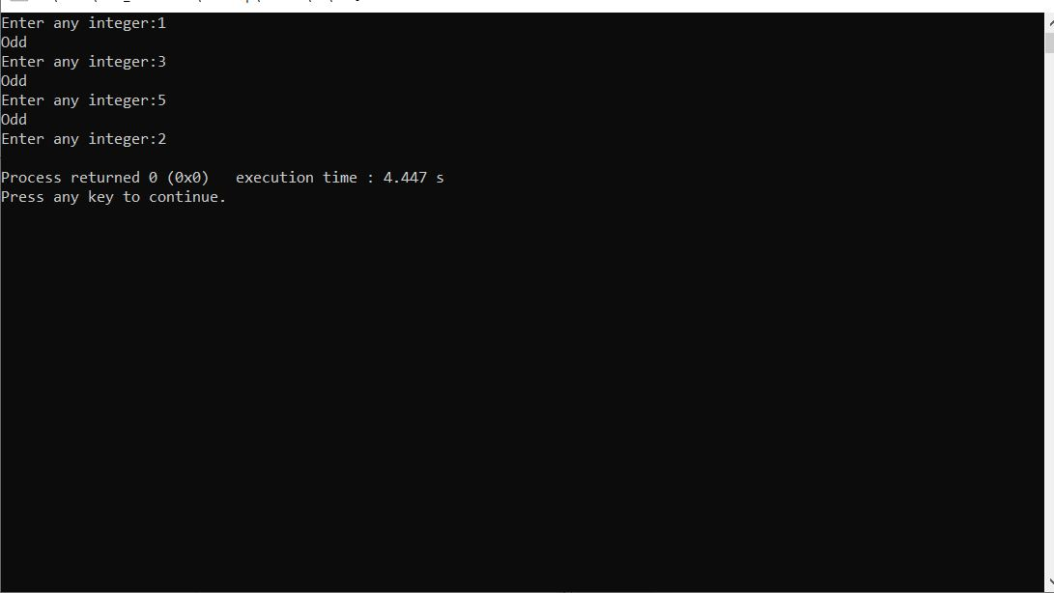

Discussion:

|  | #include<stdio.h>  int main ()  {  int x;  do{  printf("Enter any integer:");  scanf("%d",&x);  x=x%2;  if(x!=0)  printf("Odd\n");  }  while(x!=0);  return 0;  } |
| --- | --- |
|  | #include<stdio.h>  int main ()  {  int x;  printf("Enter any integer:");  scanf("%d",&x);  check:  if(x%2==0)  printf("even\n");  else  { printf("odd\n");  printf("Enter any integer:");  scanf("%d",&x);  goto check;}  return 0;  } |
|  | #include<stdio.h>  int main ()  {  int x;  printf("Enter any integer:");  scanf("%d",&x);  while(x%2!=0)  {  printf("odd\n");  printf("Enter any integer:");  scanf("%d",&x);  }  printf("even\n");  return 0;  } |

1. Write a complete C code to compute the sum of the cubes of the first n counting numbers, and store this value in total.   
   Thus if n equals 4, your code should put 1*1*1 + 2*2*2 + 3*3*3 + 4*4*4 into total.

Answers:

KAMAL AIZIM

#include<stdio.h>

int main()

{

int k, total, n;

printf("Enter the first n counting numbers:");

scanf("%d",&n);

total=0;

k = 1;

while (k <= n) {

total += k * k * k;

printf("%d*%d*%d\n", k,k,k);

if(k<=n-1)

printf(" + ");

k++;

}

printf(" = %d\n\n", total);

return 0;

}

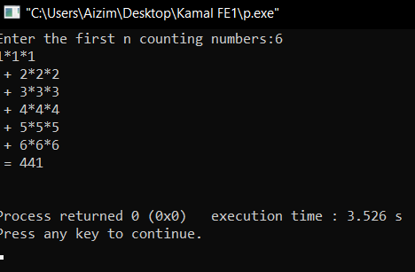

5)Write a program that generates a table of conversions from Fahrenheit $(℉)$ to Celsius $(℃)$ for values from 0 $℉$ to 100 $℉$ in 5-degree increment. The conversion formula is: $Celsius=5.0/9.0×(Fahrenheit-32)$

Answers:

IRFAN HAIQAL

#include<stdio.h>

int main()

{

float c, f=0;

printf("Farenheit to Celsius in 5-degree increments \n\n");

printf("Fahrenheit(F) | Celsius (C) \n");

printf("--------------------------------------\n");

while(f<=100)

{

c =(5.0/9.0)*(f-32);

printf("\n%.1f Fahrenheit = %.2f Celsius\n", f, c);

f+=5;

}

return 0;

}

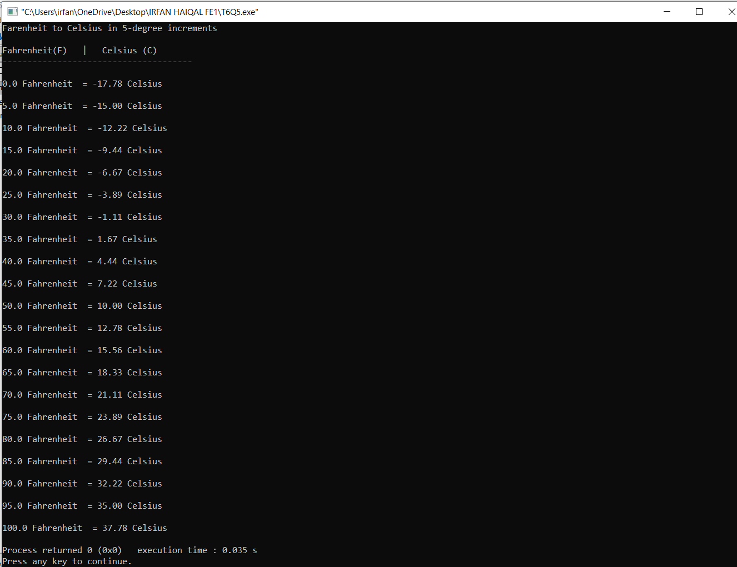

6)Assume that there are 14,000 acres total with 2500 acres uncut, and that the reforestation rate is 0.02. Write a program that prints a table showing the number of acres forested at the end of each year, for a total of 20 years. The following is the sample output:  
  
 YEAR FORESTED ACRES AT END OF YEAR

----------------------------------------

0 2500.00

1 2550.00

2 2601.00

… …

19 3642.03

20 3714.87

Answers:

KHAIRI

#include <stdio.h>

#define REFOREST_RATE 0.02

#define UNCUT_ACRES 2500

#define MAX_YEARS 20

int main()

{

int year=0;

double forested = UNCUT_ACRES;

printf("YEAR FORESTED ACRES AT END OF YEAR\n");

printf("--------------------------------------\n");

while (year <= MAX_YEARS)

{

printf("%5d %7.2lf\n",year,forested);

forested += REFOREST_RATE*forested;

year++;

}

return 0;

}

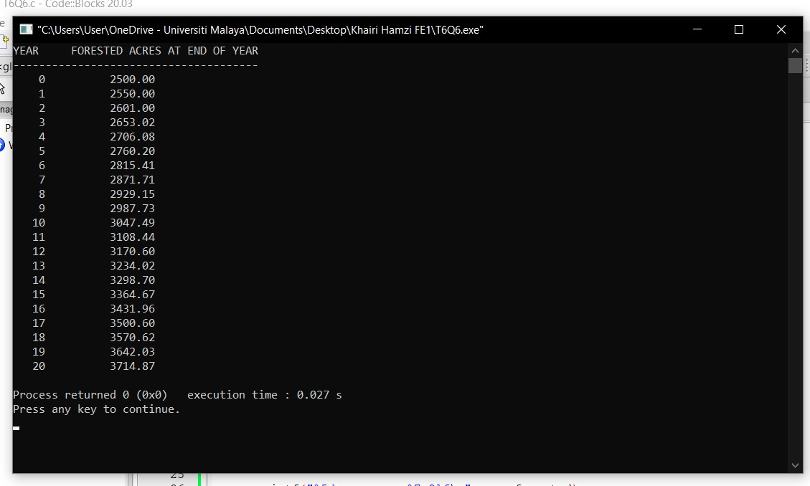

7)Modify the solution to problem Q6 so that the user can enter the number of acres and the program will determine how many years are required for the number of acres to be completely reforested.

Hint:





Answers:

IKMAL

#include <stdio.h>

#define REFOREST_RATE 0.02

int main()

{

int year=0;

double UNCUT_ACRES=2500;

double MAX_ACRES=14000;

double forested = UNCUT_ACRES, acres=UNCUT_ACRES-1;

printf("MAXIMUM number of acres to reforest: %.0lf\n",MAX_ACRES);

printf("MINIMUM number of acres: %.0lf\n",UNCUT_ACRES);

while ((acres>MAX_ACRES) || (acres<UNCUT_ACRES))

{

printf("Enter acres to be reforested: ");

scanf("%lf",&acres);

}

printf("\nYEAR FORESTED ACRES AT END OF YEAR \n");

printf("-------------------------------------- \n");

while (forested <= acres)

{

printf("%5d %7.2lf\n",year,forested);

forested += REFOREST_RATE*forested;

year++;

}

printf("\nUp to %d years are required to reforest %.2lf acres\n",year,acres);

return 0;

}

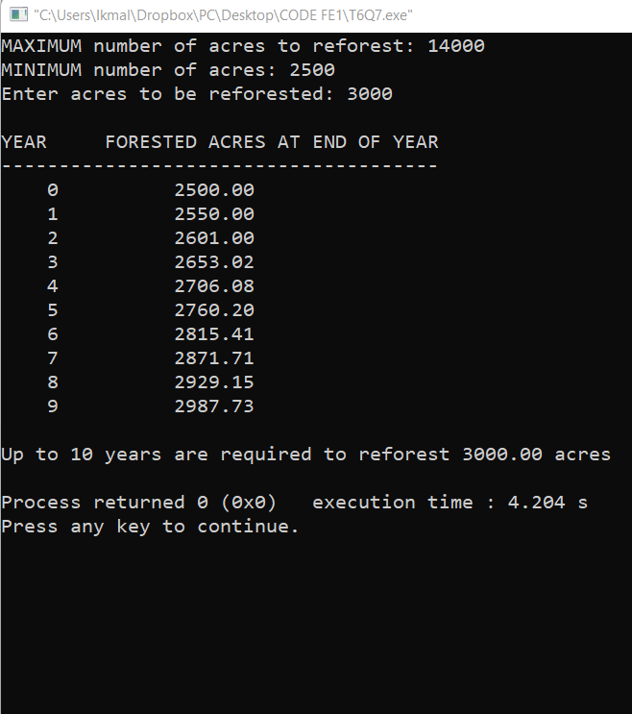

8)Write a program to allow the user to set a new 4 digit PIN number and reconfirm it before being allowed to enter the menu at the Auto Teller Machine(ATM).(use do...while statement).

Eg output :

set your new 4 digit PIN :2468

Please reconfirm your new PIN :1234

Please reconfirm your new PIN :4321

Please reconfirm your new PIN :2468

congratulation,you have succesfully changed your PIN

Please select yout menu or exit

THANK YOU

Answers:

IKHZAM

#include<stdio.h>

int main(void)

{

int pin, npin;

printf("set your new 4 digit PIN :");

scanf("%d",&pin);

do

{

printf("Please reconfirm your new PIN :");

scanf("%d",&npin);

}

while (npin!=pin);

printf("Congratulation,you have succesfully changed your PIN\n");

printf("Please select your menu or exit\n");

printf("THANK YOU");

return 0;

}